The effect of concentration on a reaction rate

Introduction

In this experiment, the effect of the concentration of sodium thiosulfate on the rate of reaction is investigated.

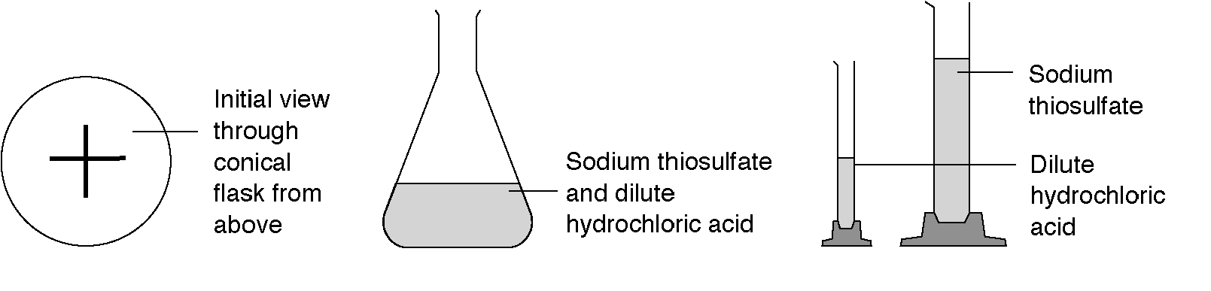

Safety

Wear eye protection. Take care not to inhale fumes.

Equipment

250 mL conical flask (2) 50 mL measuring cylinder (2) 10 mL measuring cylinder
stop watch 2 M hydrochloric acid 0.25 M sodium thiosulfate
distilled water paper permanent marker

Procedure

1. Put 50 mL of sodium thiosulfate solution in a flask.
2. Measure 5 mL of dilute hydrochloric acid in a small measuring cylinder.
3. Add the acid to the flask and immediately start the clock. Swirl the flask to mix the solutions and place it on a piece of paper marked with a cross.
4. Look down at the cross from above. When the cross disappears stop the clock and note the time. Record this in the table.
5. Repeat this using different concentrations of sodium thiosulfate solution. Make up 50 ml of each solution. Mix different volumes of the sodium thiosulfate solution with water as shown in the table.
6. As soon as possible, pour the solution into the container in the fume cupboard.

Observations

_____________________________________________________________________

_____________________________________________________________________

_____________________________________________________________________

_____________________________________________________________________

Volume of sodium thiosulfate solution (mL) | Volume of water (mL) | Time taken for cross to disappear (s) | Original concentration of sodium thiosulfate solution (mol L⁻¹) | ¹/_{time}  (s^{–1})
50 | 0 |  | 0.25
40 | 10 |  | 0.20
30 | 20 |  | 0.15
20 | 30 |  | 0.10
10 | 40 |  | 0.05

Processing data

1. For each set of results, calculate the value of 1/time. (This value can be taken as a measure of the rate of reaction).

2. Plot a graph of 1/time taken on the vertical (y) axis and concentration on the horizontal (x) axis.

- Why do we plot the graph of 1/time as opposed to time?

- What effect does the concentration of sodium thiosulfate have on the reaction
rate? Explain why.

- Why did we add water at each step? Why not just change the amount of sodium
thiosulfate?

- If the concentration of sodium thiosulfate is doubled, what happens to the rate of
reaction? Use data from your graph to explain why.

- Why did we draw a cross on a piece of paper for this experiment? What is another
method we could have used to achieve a similar goal? (Hint: SO₂ is normally a
gas, but just dissolved in solution momentarily)

- Identify two random errors in this experiment. How could these errors be
minimised?



